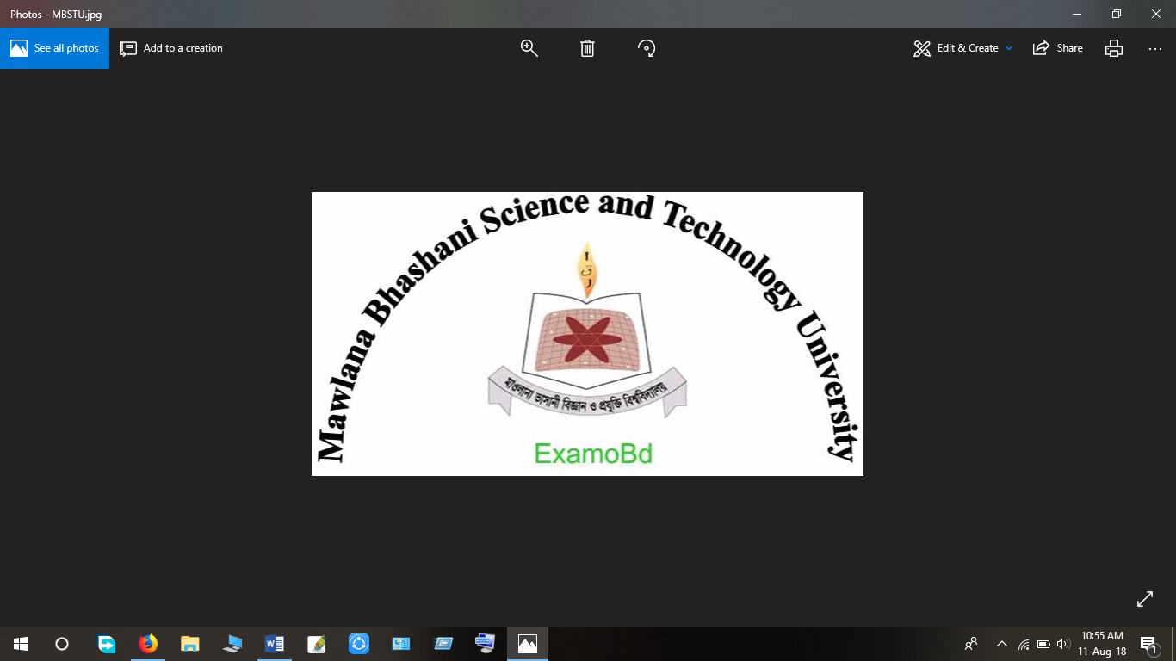

**Project Report**

**Department:** Computer Science and Engineering

**Project Name: Android application for Student management.**

**Team Name: A.M Mahmudul Alam &** **Tushar Miah**

Course Title: Software Development Project-II and Industrial Tour

# Course Code: CSE3116

**Submitted To Submitted By**

Md.Mezbahul Islam Name: A.M.Mahmudul Alam

Assistant Professor, ID: CE-18058

Dept. of CSE, MBSTU, Name: Tushar Miah

Santosh, Tangail. ID: CE18054

Year: 3rd Semester: 1st

Session: 2017-18

**Project Title:** **Android application for Student management**

**Team Profile:**

**Member - 01: Member - 02:**

Name:A.M.Mahmudul Alam Name: Tushar Miah

ID: CE18058 ID: CE18054

**Individual Contributions:**

|  |  |  |  |  |  |
| --- | --- | --- | --- | --- | --- |
| Student Information | Requirements Specification | Software Design | Coding | Debugging & Testing | Report Preparation |
| A.M.MahmudulAlam,CE18058 | **✔** | **✔** | **✔** | **✔** | **✔** |
| Tushar MIah,  CE18054 | **✔** |  |  | **✔** |  |

**Table of Contents**

[Project Description 4](file:///C:\Users\ASUS\Downloads\Project%20Report%20(1).docx#_Toc85163719)

[Analysis & Domain Modeling 5](file:///C:\Users\ASUS\Downloads\Project%20Report%20(1).docx#_Toc85163720)

[Project Management 6](file:///C:\Users\ASUS\Downloads\Project%20Report%20(1).docx#_Toc85163721)

[Interaction Diagram 7](file:///C:\Users\ASUS\Downloads\Project%20Report%20(1).docx#_Toc85163722)

[Class Diagram & Interface Specifications 8](file:///C:\Users\ASUS\Downloads\Project%20Report%20(1).docx#_Toc85163723)

[Data Structures 8](file:///C:\Users\ASUS\Downloads\Project%20Report%20(1).docx#_Toc85163724)

[User Interface Design & Implementation 9](file:///C:\Users\ASUS\Downloads\Project%20Report%20(1).docx#_Toc85163725)

[Design of Tests 10](file:///C:\Users\ASUS\Downloads\Project%20Report%20(1).docx#_Toc85163726)

[Plan of Work 14](file:///C:\\Users\\ASUS\\Downloads\\Project%20Report%20(1).docx" \l "_Toc85163727)

[References 15](file:///C:\\Users\\ASUS\\Downloads\\Project%20Report%20(1).docx" \l "_Toc85163728)

# 

# Project Description

This project is developed using Java language. At first, the user has to install the app to get access. This system helps to display the student information easily as it is not time-consuming then the user can add student marks, modify, delete as well as view the records. Save student’s information, and it displays the marks individually after entering student Roll number. This project is easy to operate, user-friendly, and understood by the users

# Analysis & Domain Modeling:

**a. Conceptual Model:**

*Student management* system is a great way to stay on top of your tasks and be productive. It is very easy- to- use which lets you manage your tasks within time

Add

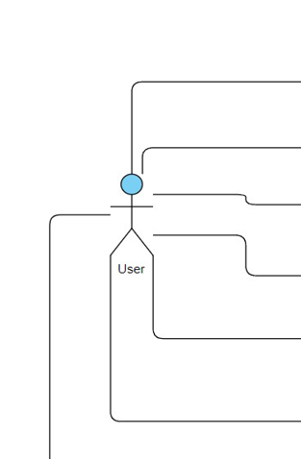 Modify

Delete

View

View All

Exit

Fig: **Use Case Diagram for Student Management System**

1. **System Operation Contracts:** 
   * + The add task function allows the user to add marks.
     + Through the modify task function, the user can modify the information.
     + The delete task function allows the user to delete the task as he wishes.
     + The view expense function allows the user to view a specific list of expenses.
     + The view all function allows the user to view a specific list of expenses.
     + The exit function allows the user to exit the system.

# 

# Project Management

The project is totally managed by admin. He can do any kind of change or any update anytime, if he wants.

The total system is also controlled by the admin

# Interaction Diagram

**Open**

Object Function

**Roll NNumber**

**Name**

**Marks**

**Add/Modify/Delete/View**

Fig: Interaction Diagram

**Interface Specifications:**

# Data Structures

**ArrayList:**

In this project, we have a database (Student Roll, Name, Mark list). Here, we make a connection between sqlite database. We store all the data in the database.

We have to store those values of database into our code. To store those values, we use ArrayList in our code. We also display those values using it.

There are many ways to store and display those values from database.

But for which reasons, we decide to use ArrayList are given bellow:

1. It is a dynamic array.

2. It is a resizable array.

3. No need to define any fixed particular size.

4. It automatically changes the size when we add or remove items

from it.

5. It is more flexible to use than other data structures.

6. It reduces our required memory.

7. Most importantly, as we create object here, we can access any

data types in it without mentioning them.

8. It has a lot of build in functions which helps to make code easy.

# User Interface Design & Implementation

Here, we try our best to create an easy user interface (UI) for the users in this project.

Every button has a specific name. The name is given for which particular work it is created. So, a user can easily understand that how to move from one particular page to another.

Firstly, we mainly focus on our requirements. We find all the requirements for our project. Then, we create the interface for this system. Making the user interface easy, we create buttons to controlling it.

At last, we implement these user interfaces. Here, we build up our whole project with java and database. For this we create connection between netbeans and mysql. Then, we write our necessary code to implement those user interfaces.

Thus, we developed our initial phase of this project.

For making further progress of this project, we use unit testing, integration testing, validity testing and at last validity testing. In this part, if we get any error, we again update our code and make the implementation correct. Like as, Code & Fix model.

Thus, we build our overall user interface design and implementation of this project.

# Design of Tests

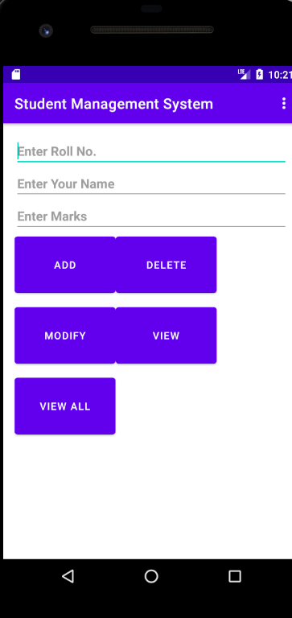

**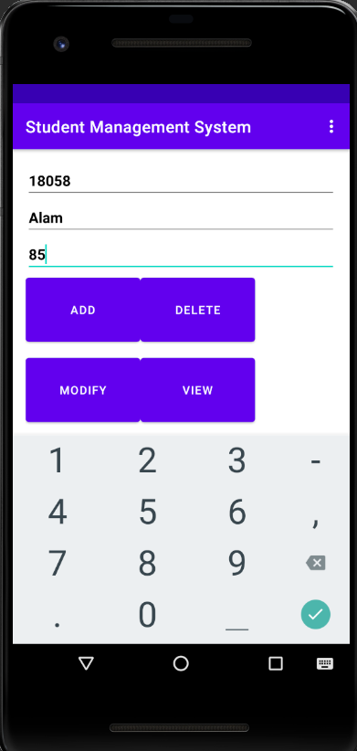**

**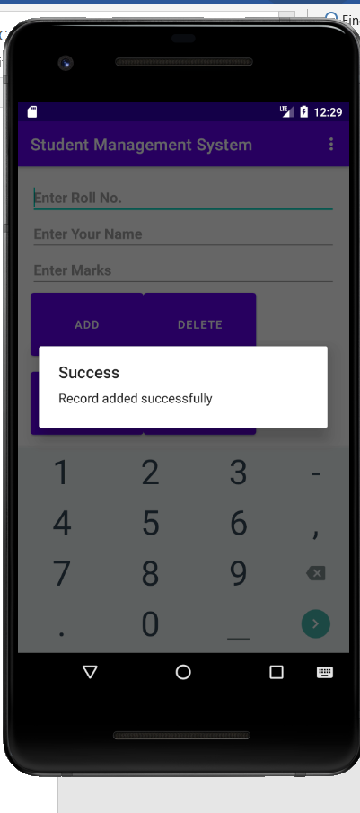**

**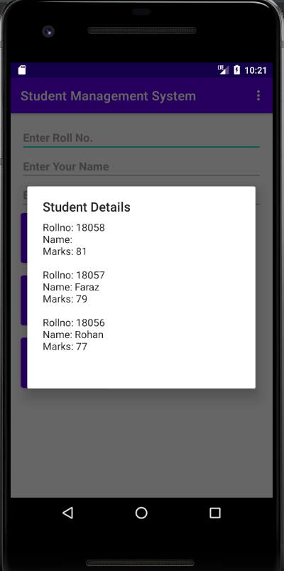**

**Unit Testing:**

In this part, we will test our every individual part of our project. “Is our every page is working correctly?”, we will test in this part.

**Integration Testing:**

In this project, there are some parts where if we change anything it will make changes two or more places.

In this part, we will test those parts, “are the working properly or not?”

# Plan of Work

Project Period – 2021

|  |  |  |  |  |  |  |  |  |  |  |
| --- | --- | --- | --- | --- | --- | --- | --- | --- | --- | --- |
| Activities | Jan | Feb | Mar | Apr | May | Jun | Jul | Aug | Sept | Oct |
| Topic Specification |  |  |  |  |  |  |  |  |  |  |
| Requirements Finding |  |  |  |  |  |  |  |  |  |  |
| Software Design |  |  |  |  |  |  |  |  |  |  |
| Methodology Development |  |  |  |  |  |  |  |  |  |  |
| Debugging, Testing & Updating |  |  |  |  |  |  |  |  |  |  |
| Writing & Editing Report |  |  |  |  |  |  |  |  |  |  |
| Project Submission |  |  |  |  |  |  |  |  |  |  |

# References

* <https://www.tutorialspoint.com/java/java_environment_setup.htm>
* <https://qualitestgroup.com/insights/technical-hub/how-to-add-java-to-your-system-path/>
* <https://www.infoworld.com/article/3388036/what-is-jdbc-introduction-to-java-database-connectivity.html>
* [(1576) JAVA - How To Design Login And Register Form In Java Netbeans - YouTube](https://www.youtube.com/watch?v=XAowXcmQ-kA)
* [Red CMYK color code | flatuicolorpicker : Best Flat Colors UI Design](https://www.flatuicolorpicker.com/?fbclid=IwAR1Rxk2rAtzEM5vMkvRe9_-GrVuu8W1g_4iFSyWOyInEi6uOT6Fjry1Egk8)
* [(1576) how to auto increment varchar in sql server - YouTube](https://www.youtube.com/watch?v=TUso12qJoSY)
* <http://netbeans.apache.org/kb/docs/ide/mysql.htm>
* [(1576) How to Connect to Microsoft SQL Server in NetBeans IDE | Java Connect to SQL Server | JDBC in Java - YouTube](https://www.youtube.com/watch?v=hijzCL_8rss)
* [(1576) Connect Netbeans 11.1 Java Maven Project with Microsoft SQL Server Database - YouTube](https://www.youtube.com/watch?v=ZuCft0xV6Ek)
* [(1576) How to Connect to Microsoft SQL Server in NetBeans IDE - YouTube](https://www.youtube.com/watch?v=a1WCD6Pdjt4&t=329s)
* [How to resize an image in Java - Mkyong.com](https://mkyong.com/java/how-to-resize-an-image-in-java/?fbclid=IwAR3we9vshHztxx3A5hs0SH-_b71dEUmk1zq3Hq6l7K73xAKZOnJlxG1cgzk)
* [(1576) How to Resize an Image in Java - YouTube](https://www.youtube.com/watch?v=eZrdU3BvI4E)
* <https://github.com/prmr/SoftwareDesign>
* [(1576) Employee Payroll Management System Using Java Netbeans-Part 15-Resize a picture to fit JLabel-Part 2 - YouTube](https://www.youtube.com/watch?v=JahAHzYCzxA)
* [(1576) JAVA - How To Make Image Slideshow In Java Swing - YouTube](https://www.youtube.com/watch?v=pN1uoJD_uSE)
* [How to Connect to Microsoft SQL Server in NetBeans IDE - YouTube](https://www.youtube.com/watch?v=a1WCD6Pdjt4)
* <https://www.geeksforgeeks.org/arraylist-in-java/>
* [Resize Images Online - Reduce JPG, BMP, GIF, PNG images (reduceimages.com)](https://www.reduceimages.com/?fbclid=IwAR3we9vshHztxx3A5hs0SH-_b71dEUmk1zq3Hq6l7K73xAKZOnJlxG1cgzk)
* [100+ Cricket Wallpaperss [HD] | Download Free Images & Stock Photos On Unsplash](https://unsplash.com/s/photos/cricket?fbclid=IwAR2NdE9_CyKA8nK52r_Nho5yYzzaoC-m42a6dC_wqFoU-2PrLubQLRp2x4M)
* [Open a static port in the Windows firewall for TCP access (firehousesoftware.com)](https://www.firehousesoftware.com/webhelp/FH/Content/FHEnterprise/FHEnterpriseInstallationGuide/24_StaticPort.htm?fbclid=IwAR1EJFHxTfhIaSYCSNSpiR9ykeoOdSu-aMThzWWjv48ywl-TOTb95S95mkY)
* [(1577) how to make loading screen in java netbeans | how to make splash screen using java netbeans | eclips - YouTube](https://www.youtube.com/watch?v=Gm1Jrj2vjkM)
* [Modify image | ResizePixel](https://www.resizepixel.com/edit?fbclid=IwAR0ckaExTs3dJ8lpHERi62U8I2YLAR_g8DF6Q3Q5KL38elQH1bAzbFYr3yo)
* [(1577) How to Make Splash Screen in Java Using Eclipse||How to Add Gif in Java - YouTube](https://www.youtube.com/watch?v=vxH7UTgEHhk)